7
EXPLAIN PLAN SET STATEMENT_ID = 'st1' FOR select * from mobile_data@newarchicom --where time >= to_date('01/09/2012 00:00:00' , 'DD/MM/YYYY HH24:MI:SS') --and time <= to_date('30/09/2012 23
:59:59' , 'DD/MM/YYYY HH24:MI:SS') where substr(cdrfilename, 1,15) between '3g3glf_00124907' and '3g3glf_00125968' and postpre = 'roa');

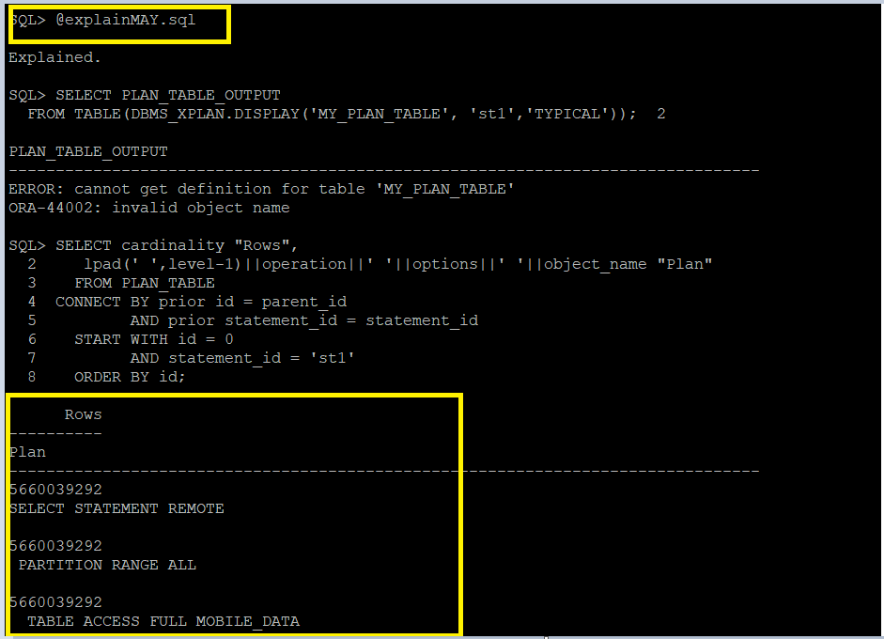

EXPLAIN PLAN SET STATEMENT_ID = 'st2' FOR select * from mobile_data@archicom --where time >= to_date('01/09/2012 00:00:00' , 'DD/MM/YYYY HH24:MI:SS') --and time <= to_date('30/09/2012 23:59:59' , 'DD/MM/YYYY HH24:MI:SS') where substr(cdrfilename, 1,9) between 'b00203152' and 'b00203152' and postpre = 'roa' ) ;

SELECT cardinality "Rows",
lpad(' ',level-1)||operation||' '||options||' '||object_name "Plan"
FROM PLAN_TABLE
CONNECT BY prior id = parent_id
AND prior statement_id = statement_id
START WITH id = 0
AND statement_id = 'st2'
ORDER BY id;
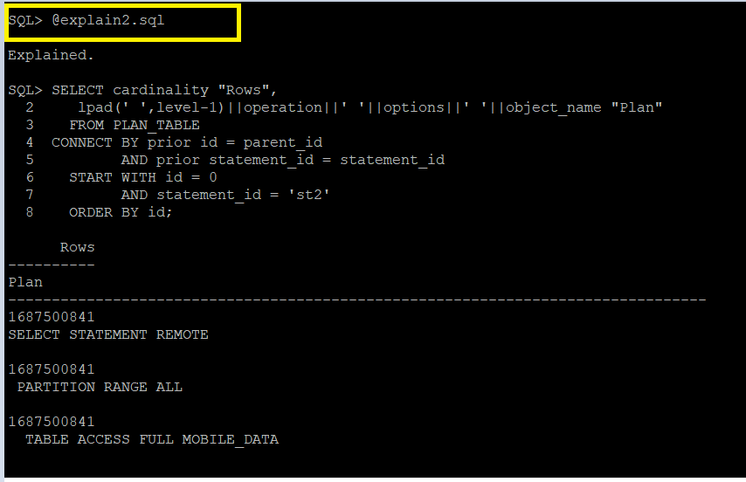

EXPLAIN PLAN SET STATEMENT_ID = 'st3' FOR select * from mobile_data@archicom --where time >= to_date('01/09/2012 00:00:00' , 'DD/MM/YYYY HH24:MI:SS') --and time <= to_date('30/09/2012 23:59:59' , 'DD/MM/YYYY HH24:MI:SS') where substr(cdrfilename, 1,9) between 'b00203153' and 'b00204032' and postpre = 'roa';

SELECT cardinality "Rows",
lpad(' ',level-1)||operation||' '||options||' '||object_name "Plan"
FROM PLAN_TABLE
CONNECT BY prior id = parent_id
AND prior statement_id = statement_id
START WITH id = 0
AND statement_id = 'st3'
ORDER BY id;
