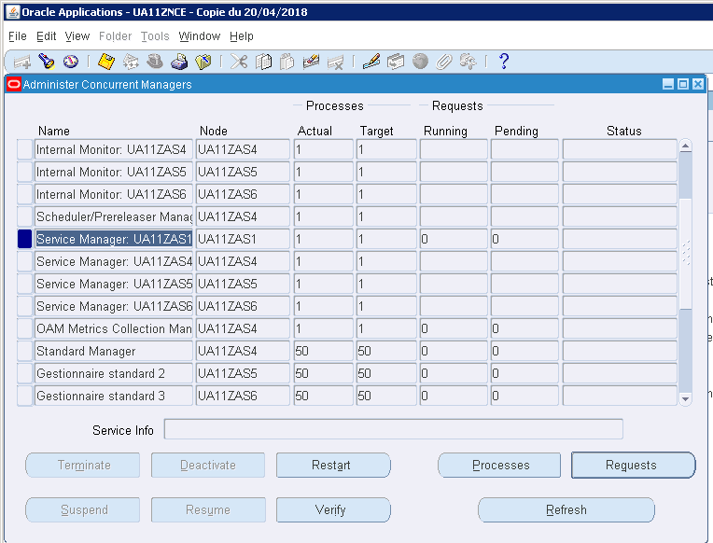
I have only restart button. I tried to play with process making 1 process to get actual=target and then deactivate , it doesn’t work.
For the other nodes, I let process =0: same behavior, no box to deactivate (gray).
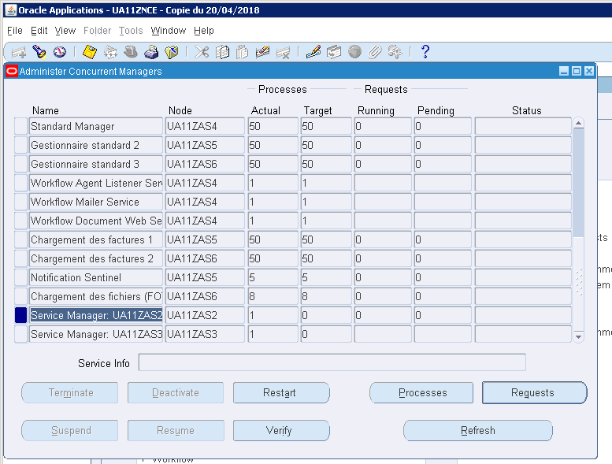

I have no process on the servers for this managers.

