- all concurrent managers are stopped:
- with adcmctl.sh stop on the the node4 and node5 (because Internal manager have a primary node “node4” and secondary node “node5”). Nothing on the last server node6 (CM server too) and services goes down automatically.
To disable Service Manager: node1, I tried to uncheck the box : enabled, this is the message I have:


To deactivate this manager, I can’t do it because I have the following screen:
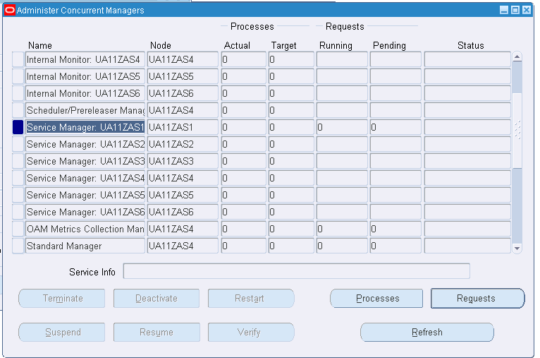
Even I put 0 processes in work shifts screen:
