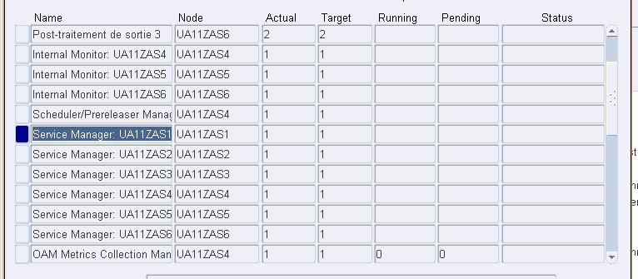

I would like to disable Service Manager: UA11ZAS1, Service Manager: UA11ZAS2 and Service Manager: UA11ZAS3 because UA11ZAS1, UA11ZAS2 and UA11ZAS3 are Web servers no need to them there.
When I go to define and look for them and try to uncheck “enabled”, it rejected me.

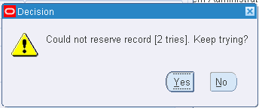
(of course, in work shifts, I could put “0 processes” to not let them run in the system).

NB: Oracle EBS r12.1.3 and RAC DB 12c

