RCU
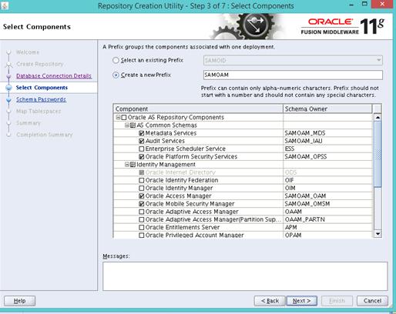
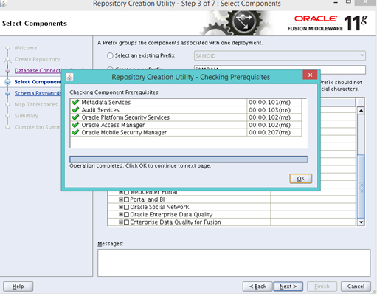
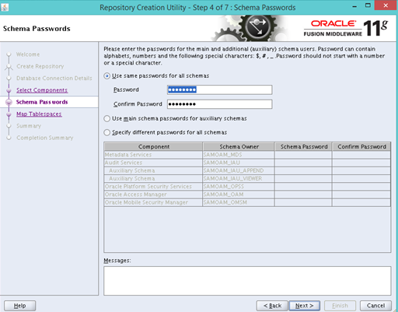
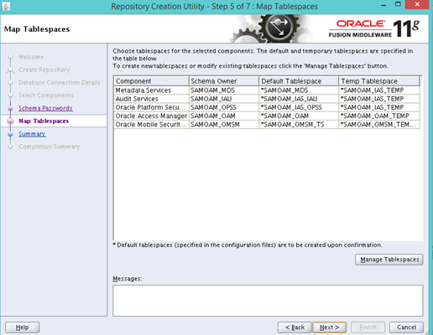
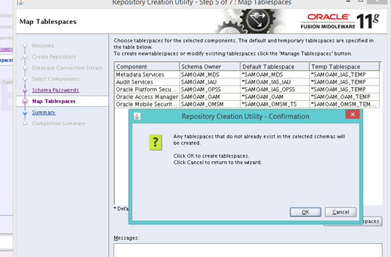

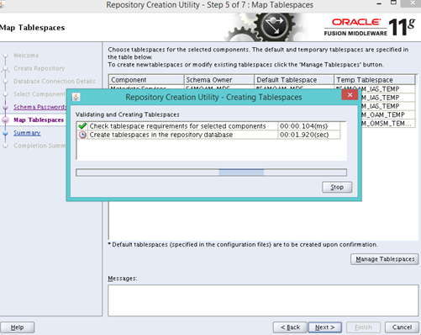
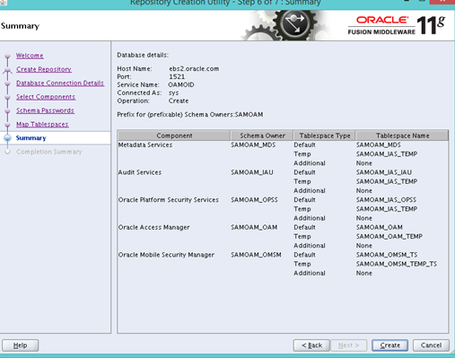

Weblogic installation done
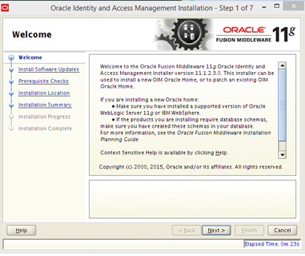
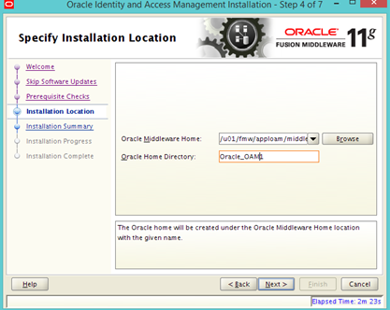

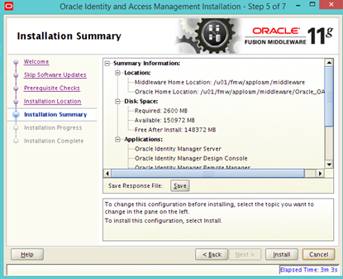

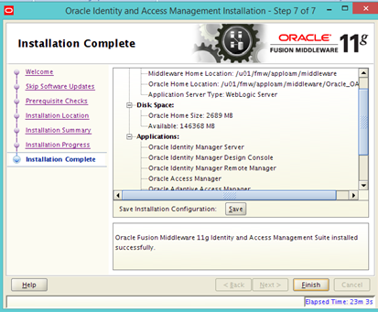
Running config.sh
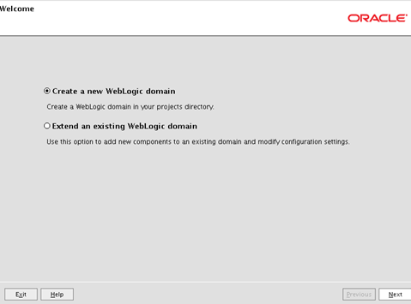
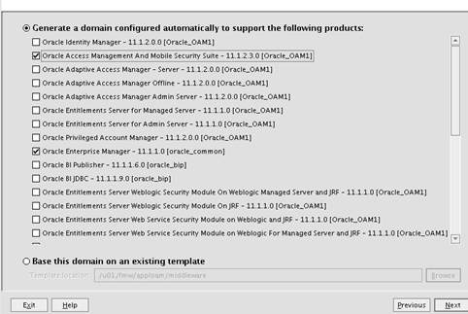

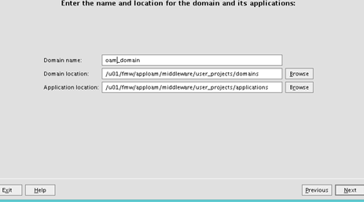
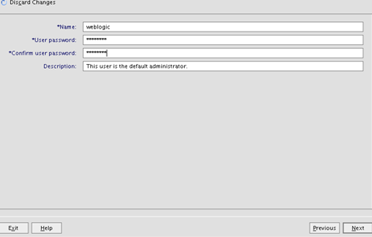
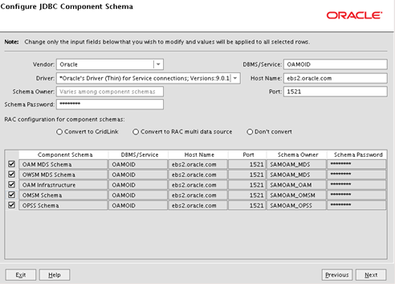

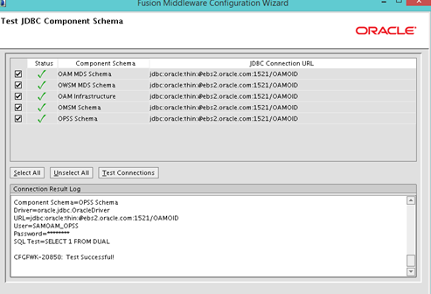

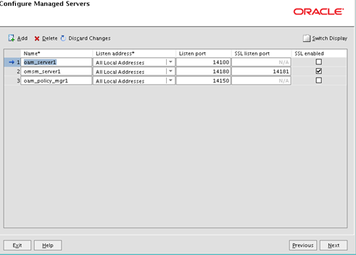

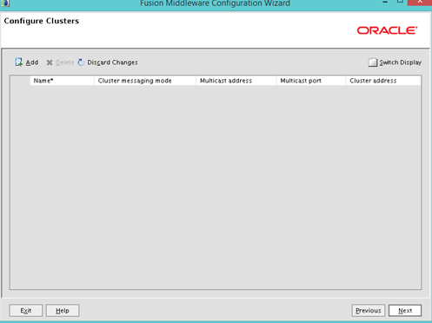

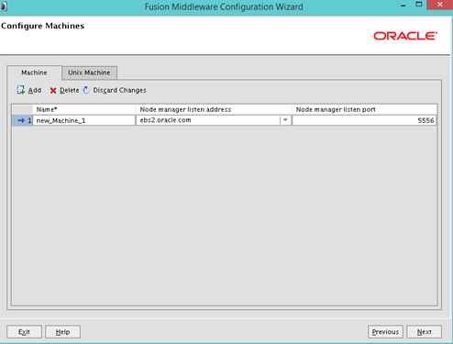

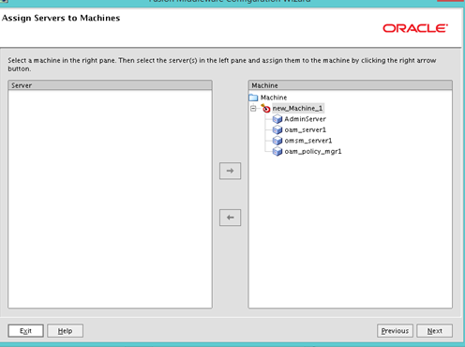

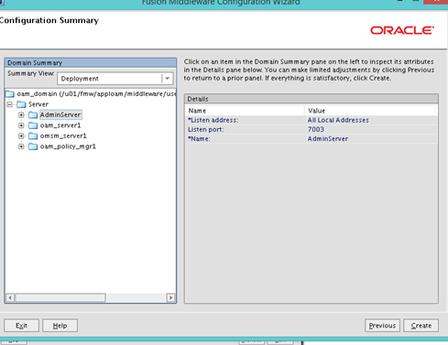

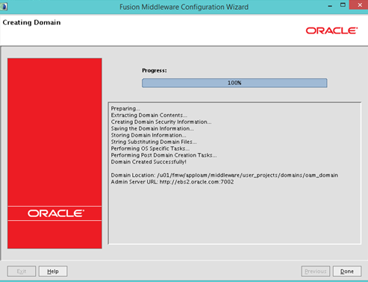

Configuring Database Security Store for an Oracle Identity and Access Management Domain

/u01/fmw/apploam/middleware/oracle_common/common/bin/wlst.sh /u01/fmw/apploam/middleware/Oracle_OAM1/common/tools/configureSecurityStore.py -d /u01/fmw/apploam/middleware/user_projects/domains/oam_domain -c IAM -p Dumka56# -m create

CLASSPATH=/u01/fmw/apploam/middleware/patch_wls1036/profiles/default/sys_manifest_classpath/weblogic_patch.jar:/u01/fmw/apploam/middleware/patch_ocp371/profiles/default/sys_manifest_classpath/weblogic_patch.jar:/u01/fmw/jdk1.7.0_141/lib/tools.jar:/u01/fmw/apploam/middleware/wlserver_10.3/server/lib/weblogic_sp.jar:/u01/fmw/apploam/middleware/wlserver_10.3/server/lib/weblogic.jar:/u01/fmw/apploam/middleware/modules/features/weblogic.server.modules_10.3.6.0.jar:/u01/fmw/apploam/middleware/wlserver_10.3/server/lib/webservices.jar:/u01/fmw/apploam/middleware/modules/org.apache.ant_1.7.1/lib/ant-all.jar:/u01/fmw/apploam/middleware/modules/net.sf.antcontrib_1.1.0.0_1-0b2/lib/ant-contrib.jar::/u01/fmw/apploam/middleware/oracle_common/modules/oracle.jrf_11.1.1/jrf-wlstman.jar:/u01/fmw/apploam/middleware/oracle_common/common/wlst/lib/adfscripting.jar:/u01/fmw/apploam/middleware/oracle_common/common/wlst/lib/adf-share-mbeans-wlst.jar:/u01/fmw/apploam/middleware/oracle_common/common/wlst/lib/mdswlst.jar:/u01/fmw/apploam/middleware/oracle_common/common/wlst/resources/auditwlst.jar:/u01/fmw/apploam/middleware/oracle_common/common/wlst/resources/igfwlsthelp.jar:/u01/fmw/apploam/middleware/oracle_common/common/wlst/resources/jps-wlst.jar:/u01/fmw/apploam/middleware/oracle_common/common/wlst/resources/jps-wls-trustprovider.jar:/u01/fmw/apploam/middleware/oracle_common/common/wlst/resources/jrf-wlst.jar:/u01/fmw/apploam/middleware/oracle_common/common/wlst/resources/oamap_help.jar:/u01/fmw/apploam/middleware/oracle_common/common/wlst/resources/oamAuthnProvider.jar:/u01/fmw/apploam/middleware/oracle_common/common/wlst/resources/ossoiap_help.jar:/u01/fmw/apploam/middleware/oracle_common/common/wlst/resources/ossoiap.jar:/u01/fmw/apploam/middleware/oracle_common/common/wlst/resources/ovdwlsthelp.jar:/u01/fmw/apploam/middleware/oracle_common/common/wlst/resources/sslconfigwlst.jar:/u01/fmw/apploam/middleware/oracle_common/common/wlst/resources/wsm-wlst.jar:/u01/fmw/apploam/middleware/utils/config/10.3/config-launch.jar::/u01/fmw/apploam/middleware/wlserver_10.3/common/derby/lib/derbynet.jar:/u01/fmw/apploam/middleware/wlserver_10.3/common/derby/lib/derbyclient.jar:/u01/fmw/apploam/middleware/wlserver_10.3/common/derby/lib/derbytools.jar::

Initializing WebLogic Scripting Tool (WLST) ...

Jython scans all the jar files it can find at first startup. Depending on the system, this process may take a few minutes to complete, and WLST may not return a prompt right away.

WARNING: IAU:IAU-6012: Unable to determine the audit log directory. No log directory specified.
Mar 01, 2017 11:56:25 AM oracle.security.jps.util.JpsUtil disableAudit
INFO: JpsUtil: isAuditDisabled set to true
Mar 01, 2017 11:56:25 AM oracle.security.jps.internal.audit.AuditServiceImpl validateLogPossible
WARNING: No audit log directory is set. Cannot perform audit operations for component JPS.
persist to output: /u01/fmw/apploam/middleware/user_projects/domains/oam_domain/config/fmwconfig - done
Mar 01, 2017 11:56:45 AM oracle.security.audit.Auditor init
WARNING: IAU:IAU-6012: Unable to determine the audit log directory. No log directory specified.
Mar 01, 2017 11:56:45 AM oracle.security.jps.util.JpsUtil disableAudit
INFO: JpsUtil: isAuditDisabled set to true
Mar 01, 2017 11:56:45 AM oracle.security.jps.internal.audit.AuditServiceImpl validateLogPossible
WARNING: No audit log directory is set. Cannot perform audit operations for component JPS.
Using default context in /u01/fmw/apploam/middleware/user_projects/domains/oam_domain/config/fmwconfig/jps-config-migration.xml file for credential store.
Credential store location : jdbc:oracle:thin:@ebs2.oracle.com:1521/OAMOID
Mar 01, 2017 11:57:08 AM oracle.security.audit.Auditor init
WARNING: IAU:IAU-6012: Unable to determine the audit log directory. No log directory specified.
Mar 01, 2017 11:57:08 AM oracle.security.jps.util.JpsUtil disableAudit
INFO: JpsUtil: isAuditDisabled set to true
Mar 01, 2017 11:57:08 AM oracle.security.jps.internal.audit.AuditServiceImpl validateLogPossible
WARNING: No audit log directory is set. Cannot perform audit operations for component JPS.
Credential with map Oracle-IAM-Security-Store-Diagnostics key Test-Cred stored successfully!

Credential for map Oracle-IAM-Security-Store-Diagnostics and key Test-Cred is:
GenericCredential
Info: diagnostic credential created in the credential store.
Info: Create operation has completed successfully.

